Audio Melody Extraction:
Evaluation and Approaches
Enmao Diao
Georgia Institute of Technology, Atlanta, GA, US
emdiao@gatech.edu

Abstract—A well-trained musician is able to analyze an audio recording of music, as the complexity grows, it becomes inefficient and costly to rely on human skill. To describe a comprehensive status quo of Audio Melody Extraction Task, an evaluation of the results provided by MIREX (Music Information Retrieval Evaluation eXchange) through 2009 to 2014 is conducted.
Index Terms—Fundamental pitch detection, melody extraction, evaluation, Audio, music

Introduction
Melody attracts listeners not only with joy but also with mystery. Digital signal processing stands out to lift the veal. Researchers have utilized modern technology to analyze audio recording of music to analyze its different characteristics like pitch, chord and beat. It may seem trivial for a well-trained musician to transcribe music to pitches at given time frames. However, as the complexity of overlapping and intertwining of harmonics increases, this task, audio melody extraction, becomes challenging.
In ISMIR (The International Society of Music Information Retrieval) 2004, several tasks were hosted like melody extraction, genre calassification/artist identification, tempo induction and rhythm calcification. This leads to the establishment of MIREX. The results of audio melody extraction task from 2005 to 2014 shows that the maximum Overall Accrucy increased about 4% and maximum RPA (Raw Pitch Accuracy) increased about 10%. However, from 2009 through 2014, we do not achieve a significant breakthrough as shown in Fig. 1 and 2.
According the official definition, MIREX audio melody extraction aims to identify the melody pitch contour from polyphonic musical audio. Pitch is expressed as the fundamental frequency at each time frame, which is conventionally 10ms apart. The task involves voice detection which is to decide wethere a frame contains “melody pitch”, and pitch detection to estimate the fundamental frequency for each time frame. Melody pitch is in many case a subjective concept which a listener would consider as the essence of that music. The most basic problem is that for polyphonic audio, four or more notes which come from different sources are overlapping at the same time and their fundamentals may be in integer ratios of each other. As a result, normal spectral analysis involves constructive and destructive interference. It becomes difficult to determine the predominant melody which is a prominent monophonic pitch sequence that can be agreed upon by most human listeners [1].
Despite the technical issues, resources are also limited to researchers. Although MIREX has been established for 10 years, only one large dataset is available while others have no more than 25 audio clips, since it is costly and time-consuming to set up a reliable dataset, as each pitch in datasets are manually labeled by trained human. Meanwhile, we do not achieve significant breakthrough from last 5 five years. It is still far from practical utilization. This paper aims to provide a summary of the results from 2009 through 2014 among all datasets and an analysis of approaches which are used by those who have achieved decent results.
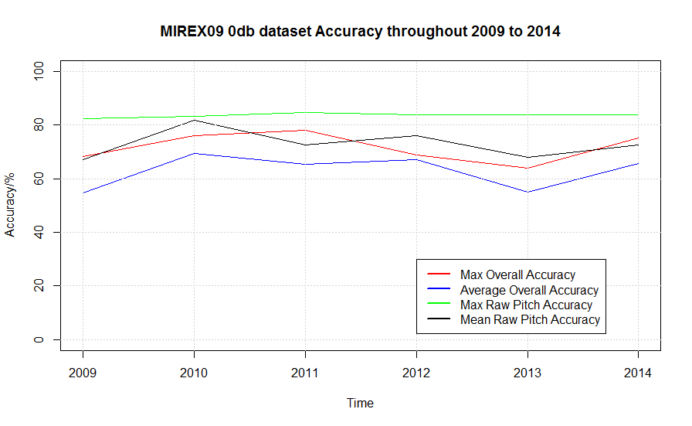
- Accuracy time analysis of dataset MIREX09 0db from 2009 through 2014.
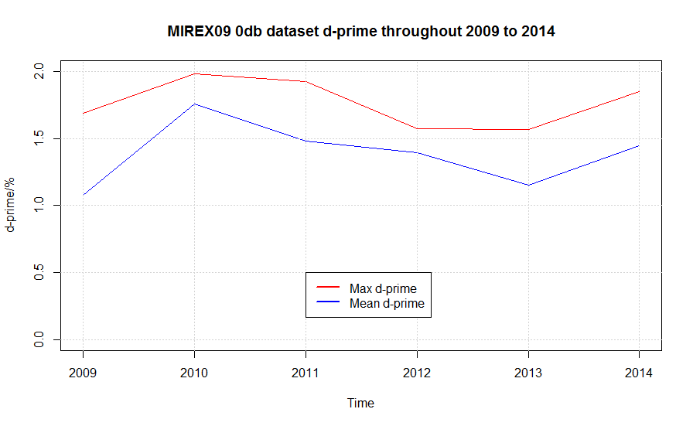
- Discrimination d’ time analysis of dataset MIREX09 0db from 2009 through 2014.

Evaluation
Pitch detection is part of the most important aspects of audio digital signal processing. Specially, pitch detection of polyphonic audio recording is rather tougher. All approaches need to identify the pre-dominant fundamental frequency for most likely melody contour through different suspected harmonics at each time frame. Moreover, it becomes clear that voice detection plays a significant role in improving overall accuracy on the basis of MIREX evaluation metrics. Since the dominant melody can be tuned on and off, most approaches are not capable of detecting voice acutely. Submission results from MIREX through 2009 to 2014 are chosen to be analyzed in this paper, on the grounds that the evaluation datasets remains unchanged through these years. Section A and B are interpreted from MIREX official website.

Evaluation Metrics
All the algorithms submitted are required to detect the pre-dominant frequency of the dominant melody at each regular time frame. The evaluation system can be divided into two parts. One is pitch detection which involves in RPA (Raw Pitch Accuracy) and RCA (Raw Chroma Accuracy). The other part involves in voice dectection which includes Voice Detection Rate and Voicing False Alarm Rate which will be introduced later. Discriminability d’ and Runtime are no longer offered after 2006. However, d’ is still provided in this paper in order to determine the effectiveness of voice detection. The voice detection system of melody extraction is based on signal detection theory shown in Table I.
- Evaluation Procedure
 |  | Detected as |  | Sum
 |  | Unvoiced | Voiced | Sum
Ground Truth | Unvoiced | TN | FP | GU
Ground Truth | Voiced | FN | TP | GV
Sum |  | DU | DV | TO

- Overall Accuracy: A measurement that contains both the voice detection and the pitch detection. It is defined as the proportion of the number of correctly labeled pitch and voicing frames over the total number of frames, i.e. (TPC + TN)/TO.

- RPA: The probability of the number of correctly labeled pitch frames (within ± ¼ tone of reference) over total number of voiced frames. Both detected as voiced and unvoiced are included as long as they are correctly labeled, i.e. (TPC + FNC)/GV.

- RCA: The probability of the number of correctly labeled chroma (i.e. the note name) frames over the voiced frames. This metric ignores the octave errors where the pitch is wrong by an exact multiple of an octave. Thus, this value is often greater than RPA, i.e. (TPCch + FNCch)/GV.

- Voicing Detection Rate: The probability that a truly voiced frame is detected as voiced, i.e. TP/GV (also known as "hit rate").

- Voicing False Alarm Rate: The probability that an unvoiced frame is detected as voiced, i.e. FP/GU.

- Voicing d-prime d’: is the sensitivity index of discriminating voiced and unvoiced frames. It can be estimated using the inverse of the cumulative distribution function of the Gaussian distribution. A larger value indicates a detection scheme with better discrimination between Voicing Detection Rate and Voicing False Alarm Rate, i.e. d' = Z(Voicing Detection Rate) − Z(Voicing False Alarm Rate) [2].

Datasets Introduction
Datasets remain unchanged from 2009 through 2014. This offers a basic foundation for data analysis. The evaluation in this paper is carried out among different datasets repectivley, since four available datasets are very distinct from each other, and they also yield diverse results.

- ADC04 database: 20 audio clips of about 20s each from the 2004 Audio Description Contest.

- MIREX05 database: 25 audio clips of 10-40s from genres including Rock, R&B, Pop, Jazz, Solo classical piano.

- MIREX08 database: 8 audio clips of 1 min from "north Indian classical vocal performances". Instruments: singing voice (male, female), tanpura (Indian instrument, perpetual background drone), harmonium (secondary melodic instrument) and tablas (pitched percussions).

- MIREX09 database: 374 Karaoke recordings of Chinese songs. Each recording is mixed at three different levels of Signal-to-Accompaniment Ratio {-5dB, 0dB, +5 dB}. Instruments: singing voice (male, female), synthetic accompaniment. The Ground Truth pitch of each clip is human labeled, with a frame size of 40ms, a hop size of 20 ms. The center of the first frame is located at 20ms. The manually labeled pitch is then interpolated to have a hop size of 10ms.

Statistical Evaluation
Statistical evaluation is conducted from 2009 through 2014. MIREX09 database is less biased because of its relatively larger quantity. Among three subsets of MIREX09 database, +5dB yields highest overall accuracy and -5db yields the lowest. Because submissions which do not perform Voice Dectection are allowed, those, which yield both Voicing Dection Rate and Vocing False Alarm Rate greater than 90% are excluded in the calculation that involves Voice Detection and Overall Accuracy. Recall that although d’ is no longer offered officially, it is calculated using the built-in R programming function [2]. Fig. 3a and 3b displays statistical summary of the Overall Accuracy and RPA among all the datasets. In order to address different approaches used by those with leading results in Section III. The histogram of Overall Accuracy is illustrated in Fig. 4a and raw pitch accuracy in Fig. 4b.
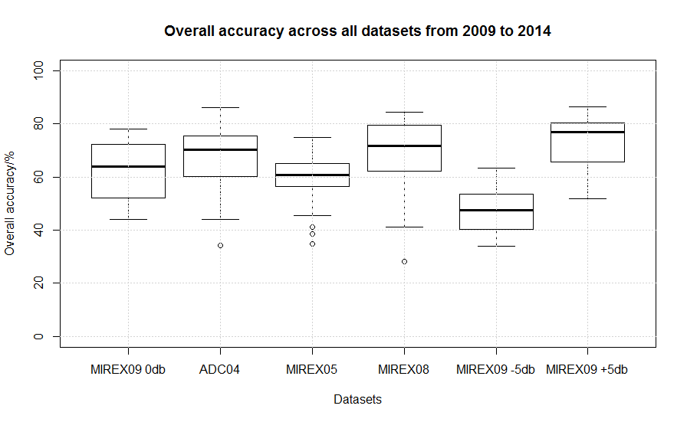
(a)
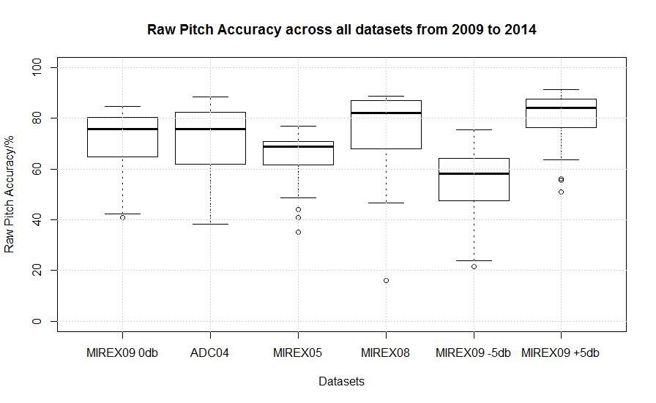
(b)
- Histogram of Overall Accuracy and Raw Pitch Accuracy.
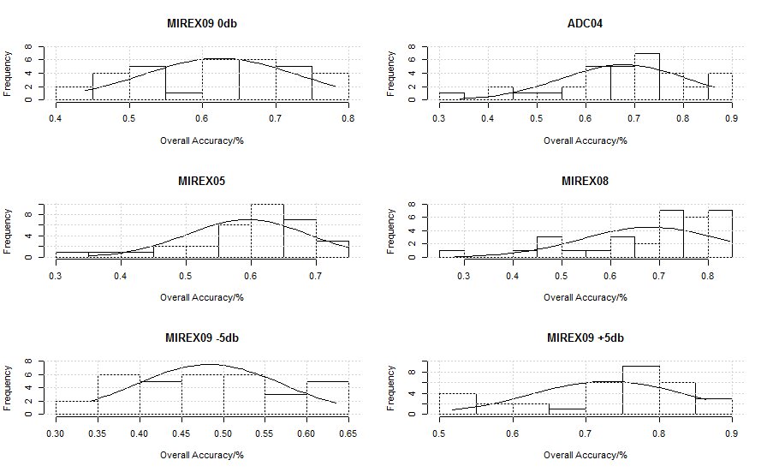
(a)
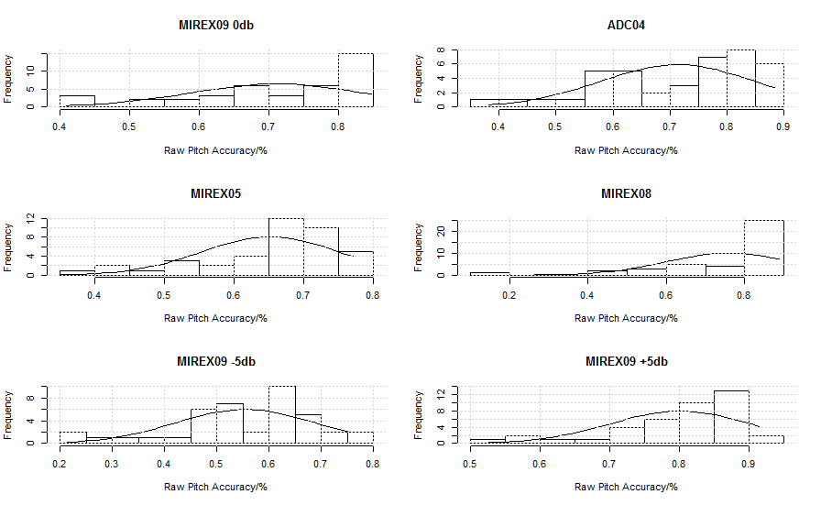
(b)
- Histogram of Overall Accuracy and Raw Pitch Accuracy.
As displayed in Fig. 3a, dataset MIREX05 with the most musical instrumental clips yields the worst overall accuracy except the MIREX09 -5db dataset. It has 9 clips of musical instrument including saxophone, guitar and synthesized piano and 15 clips of the human voice. Dataset ADC04 has one saxophone clip and 4 Musical Instrument Digital Interface (MIDI) instruments apart from the human voice. It yields relatively decent result, but it is also the smallest dataset which generates the least Voicing False Alarm Rate comparing to others because the clips may not have many unvoiced frames. MIREX08 yields the best performance. However, it contains the fewest clips including 4 different instruments. Thus, it is not practically effective [1]. If we solely concentrate on the human voice as the predominant melody, MIREX09 is the least biased considering the large number of audio clips. All other three datasets are not well-established representatives for data analysis.
As for the three subsets of MIREX09 database, as shown in Fig. 3b and Fig. 4b, -5db version has a significant shift to lower accuracy. It results from the fact that most of the algorithms are severely dependent on the energy or salience of the harmonics. Lower Signal-to-Accompaniment Ratio severely degrades their performance.
Table II displays the best algorithm with respect to the metrics for all datasets. Recall that less representative database ADC04 and MIREX08 also yield higher accuracy. Voice detection and pitch detection are not isolated problems, because most algorithms which have max Raw Pitch Accuracy also give out Best Voicing Detection Rate.

Results of best performance and its author over six datasets

Dataset | Max Overall Accuracy | Max Overall Accuracy Author | Max Raw Pitch Accuracy | Max Raw Pitch Accuracy Author | Best Voicing Detection Rate(d-prime) | Best Voicing Detection Rate Author
MIREX09 | 78.07% | Salamon | 84.71% | Salamon | 1.986 | Hsu
ADC04 | 86.30% | Dressler | 88.36% | Dressler | 2.385 | Dressler
MIREX05 | 74.84% | Dressler | 77.03% | Dressler | 1.584 | Dressler
MIREX08 | 84.44% | Salamon | 88.85% | Salamon | 2.251 | Salamon
MIREX09 -5db | 63.49% | Tachibana | 75.49% | Tachibana | 1.483 | Hsu
MIREX09 +5db | 86.38% | Doreso | 91.39% | Salamon, | 2.605 | Doreso²

Approaches|
A total of 44 submissions have been made since 2009. One author may submit twice or more in the same year and some of them submit very similar algorithms in different years. The best performing algorithm are selected from those duplicate submissions to be analyzed. Among the 40 submissions which are considered not duplicate, some of them are determined to ignore Voice Detection if their Voicing Dection Rate and Vocing False Alarm Rate are both greater than 90%. It appears that 33 submission take voice detection into account. On the basis that MIREX09 database is the least biased database, MIREX09 0db dataset is chosen to be the standard for approaches evaluation. Submissions which perform above the threshold shown in Table III are chosen to be evaluated.
- Statistical evaluation for MIREX09 0db dataset
 | Average | Threshold
RPA | 71.69% | 75%
d’ | 1.401 | 1.5
Overall Accuracy | 62.70% | N/A

Algorithm structure is divided into four parts for evaluation including multi-pitch extraction, pitch identification, window length and voice detection. Most researchers agree on the multi-pitch extraction stage. Short-time Fourier transform (STFT) is proved to be the most widely utilized approach. Among those best performing algorithms, some apply additional processes like Multi-stage Harmonic/Percussive Sound Separation (MHPSS) [4] and multi-resolution Fast Fourier Transform (MR-FFT) [5][6][7]. MHPSS or HPSS can help with preprocessing spectrum .Harmonic/Percussive Sound Separation (HPSS) does not utilize harmonic structure of sound and the previous knowledge of percussions. Instead, it treats time domain as harmonic structure and frequency domain as percussions. MHPSS utilizes one short window (15-50ms) and one long window (100-500ms). Hsu uses HPSS considering that the long window length may damage harmonic structure with strong temporal variability [9]. However, both MHPSS and HPSS achieve high up to 84% RPA. Most well performing algorithms either choose to use a fixed to about 50ms Hanning window or use variable Hanning window ranging from 5.8ms to 46ms, but there is no clue to show that variable window length is better. According to Salamon 2011 submissions, MR-FFT is proved not to play a significant role in their system since both STFT and MR-FFT yield the same Overall Accuracy [5]. STFT more likely serves as a fundamental rule for pitch identification which severely determines the RPA.
Pitch identification is the most controversial part. Some researchers attempt to use probability model like Gaussian function [4][9][10] and Hidden Markov Model (HMM) [11][12][13]. Some researchers utilize Normalized Sub-harmonic Summation (NSHS) which is originally developed by Hermes [14]. Some researchers also take advantage of timbre model or the properties of melody in order to set up experimental rules for pitch identification [4][15][16]. Probability models prove to generate an average accuracy. If algorithms only apply STFT in multi-pitch extraction stage, Gaussian model turns out to be a little bit better than HMM. A combination of NSHS and HMM achieve up to 83% RPA. However, solely relying on STFT and NSHS or Sub-harmonic Summation (SHS) only brings about 50% RPA. Algorithms which are dependent on the rules on the basis of timbre model or the properties of melody display an extreme variance of RPA. Salamon utilizes salience function which is used to estimate the mean pitch over several iterations. Different salience functions Salamon submitted in 2010 and 2011 achieve 80% and 85% RPA respectively, although both submissions have similar overall structure. Other algorithms which set up rules can only achieve around 60% RPA. Pitch identification requires much more work than multi-pitch extraction. A possible stable solution may be a combination of NSHS and HMM, while timbre model or the properties of melody can help with limiting uncertainty factors, shaping melody contour, and as a result boost up the accuracy.
Voice detection has not been taken into account specifically by most researchers. Most researchers pay very limited amount of effort in voice detection, since MIREX not only welcome algorithms which ignore Voice Detection but also avoid emphasizing overall accuracy as the ultimate benchmark. Most researchers only demonstrate their results of RPA and RCA in their papers. The most widely applied approach for voice detection is Mel-frequency cepstral coefficients (MFCC). Some researchers take advantage of probability model like Gaussian mixture model (GMM), HMM [17][18] and Mahalanobis distance [4]. Salamon also relies on salience function and contour estimation to determine the voice regarding the claim that vibrato in a contour proves it is in a melody contour. The most well performing algorithm for voice detection by Hsu utilize several approaches including Multilayer Perception (MLP), MFCC, STFT, and Cepstral Mean subtraction (CMS) [8]. However the algorithm can still be improved a lot because its Voice Detection Rate lies on about 82%. Voice detection is still an elusive topic comparing to the previous two stages.
As for post processing, most researchers realize that smoothing is necessary. Salamon removes the outliers and estimate the blank space according to contour estimation [19]. Hsu utilize trend estimation considering that the locality of contour smoothness may not be sufficient during a short period of time [20]. Besides smoothing process, Salamon and Dressler utilize multiple streaming to identify the prominent melody line by calculating salience function and rating. The statistical evaluation for approaches utilized above threshold is shown in Table IV. RPA threshold is related to multi-pitch extraction, pitch identification and window length while d’ threshold indicates Voice Detection.
Some researchers also attempt to discard spectral analysis [16][21]. Chien’s 2014 submission improves RPA from 60% to 78% after adding Q-transform to original 2011 submission. Solely relying on self-developed models on the basis of timbre information and the properties of melody do not guarantee a decent result regarding that musical standard is complex and subjective. MIDI data mining applied by Myer yield results above the average.

Multi-pitch Extraction |  | Pitch Identification |  | Window Length |  | Voice Detection
STFT | 10 | Salience function | 2 | Variable | 5 | MFCC | 5
(M)HPSS | 2 | (N)SHS | 1 | Fixed | 3 | Salience function | 2
MR-FFT | 4 | HMM | 2 |  |  | HMM | 1
Q-transform | 1 | Gaussian function | 2 |  |  | Mahalanobis distance | 1
 |  | Timbre model | 1 |  |  | NHE | 1
 |  |  |  |  |  | Power estimation | 1
Total | 17 |  | 9 |  | 8 |  | 11

Statistical evaluation for approaches above threshold

Conclusion
The contest conducted throughout these years provided a platform for individual researchers to make a quantitative comparison and evaluation of their approaches. Although we do not achieve a significant breakthrough from 2009, considering the large quantity of MIREX 09 database, for human voicing audio, we can reach up to 85% RPA and 78% Overall Accuracy.
At practical level, Query-by-humming (QbH) has already been commercially utilized and received positive feedback from the public. However, audio melody extraction is still far from being practice. We may suggest that a large and standardized database can contribute to diagnostic analysis for researchers. Moreover, we can also simulate practical condition by emphasizing voice detection. We can also treat running time as one of the metrics which is eliminated after 2006. Regardless of the fact that audio melody extraction is still far from practical use, the path is clear.

Reference

TN: Truth Negative, FN: False Negative, FP: False Positive, TP: Truth Positive, DU: Detected as Unvoiced, DV: Detected as Voiced, GU: Ground Truth Unvoiced, GV: Ground Truth Voiced, TO: Total, C: correctly labeled pitch, I: incorrectly labeled pitch, ch: chroma
A company
Normalized Harmonic Energy

